**Visualisation Assignment**

**Module:** Applied Data Science 1

**Name:** Jenivia Alex Lobo

**Line Plot**

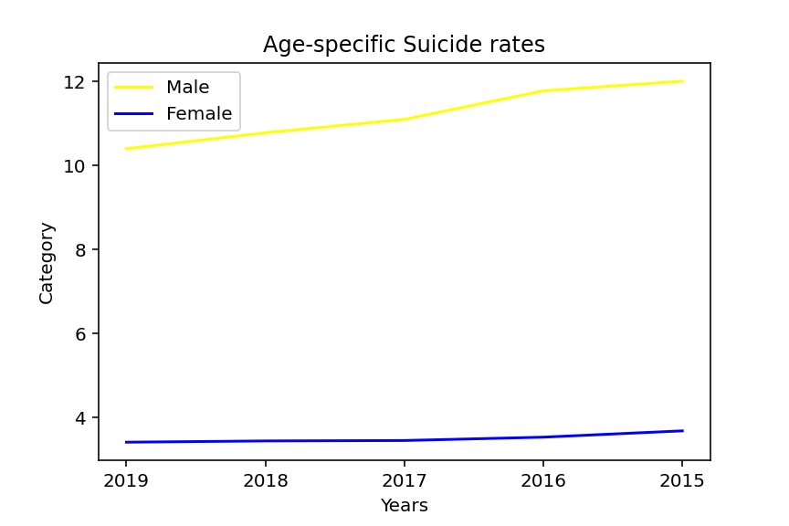

The line plot depicted above is a study of the age-specific mortality rates per 100,000 people broken down into male and female cases for the United Kingdom of Great Britain and Northern Ireland during the years 2015 to 2019. Because of numerous causes like stress, disease, and personal troubles, suicide is prevalent in developed nations. Here x-axis represents the years or the period the survey was taken and the y-axis represents the category of a person whether it was male or female. The above line plot illustrates that men have a higher suicide rate than women. As we can see from the graph, the suicide rate in Men increased from 2015 to 2017 but steadily fell from that point until 2019 The mortality rate for women was higher in 2015, although it subsequently declined and remained essentially stable. As a result, we can conclude that men had a higher suicide fatality rate than women.

**Pie Chart**

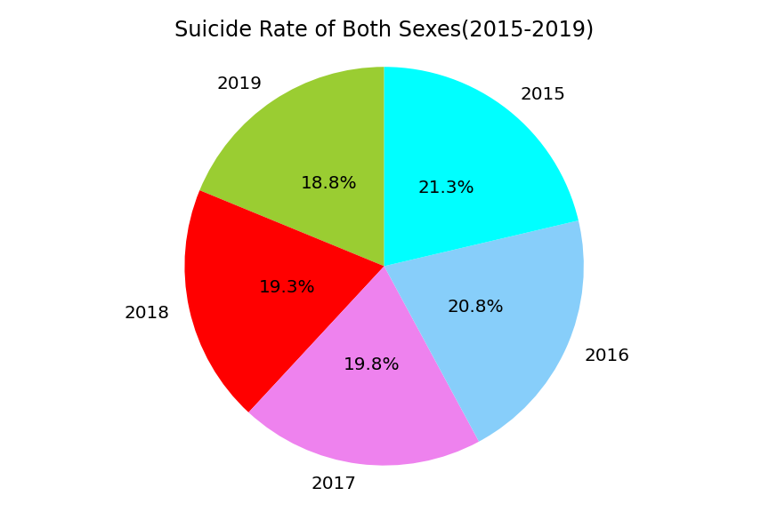

The suicide mortality rates by age for both sexes between 2015 and 2019 are shown in a pie chart. I went with the pie chart since it makes it clear which year had a greater death rate and makes comparisons easier. The pie chart was another factor in my decision because it makes the percentage of the suicide rate in each slice for each slice very evident. According to the graph, the suicide rate for both sexes peaked in 2015 and reached its lowest point in 2019. Between 2016 and 2018, it gradually declined before reaching its lowest peak in 2019. Thus, we can conclude. Increasing mental awareness caused the suicide rate to progressively fall after peaking in 2015, yet it was still quite high.

**Bar Plot**

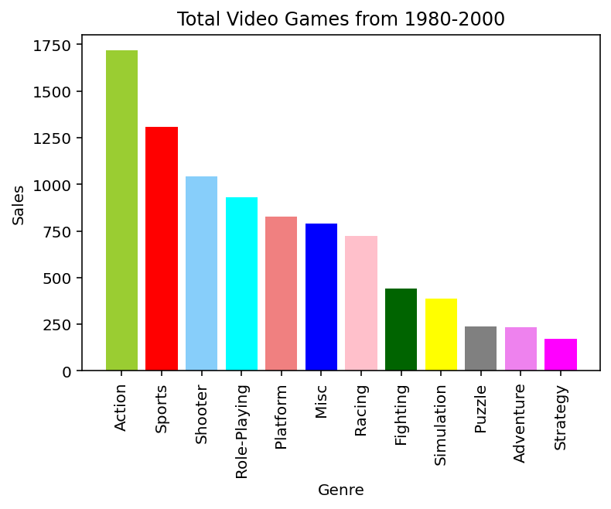

The bar graph above displays the total global sales from 1980 to 2000 broken down by genre. I selected a bar graph because it allows for quick comparison, categorizes data in proportion to values, and makes it easier to read and understand. Usually, rectangular bars are used to represent the data. Here, one axis of the bar chart reflects the genre of video games, and the other axis the value of sales. As we can see, the action genre had the biggest sales. We can also observe that sports had decent sales, while platform, misc, and racing had about equal sales. Sales of the puzzle, adventure, and strategy games were the lowest. We may deduce that the Action genre had the biggest sales and the Strategy genre had the lowest sales in the year 1980-2000.

Data sources:

Line plot n Pie:

<https://www.who.int/data/gho/data/themes/mental-health/suicide-rates>

Bar plot

<https://www.kaggle.com/datasets/stetsondone/video-game-sales-by-genre?select=genre_region_totals.csv>

GitHub link:

https://github.com/Jenivia26101996/VisualisationAssignment.git

Data sets:

 